What is a storyboard?

Once a concept or script is written for a film or animation, the next step is to make a storyboard. A storyboard visually tells the story of an animation panel by panel, kind of like a comic book.
A storyboard will should convey some of the following information:
- What characters are in the frame, and how are they moving?
- What are the characters saying to each other, if anything?
- Where the "camera" is in the scene? Close or far away? Is the camera moving?
The storyboarding process can be very tedious and intricate. The form widely known today was developed at the Walt Disney studio during the early 1930s.
One of the first live action films to be completely storyboarded was Gone with the Wind. William Cameron Menzies, the film's production designer, was hired by David Selznick to design every shot of the film. Many large budget silent films were also storyboarded but most of this material has been lost during the reduction of the studio archives during the 1970s.
Some live-action film directors, such as Joel and Ethan Coen, used storyboard extensively before taking the pitch to their funders, stating that it helps them get the figure they are looking for since they can show exactly where the money will be used. Alfred Hitchcock's films were strongly believed to have been extensively storyboarded to the finest detail by the majority of commentators over the years, although recent research indicates that this was exaggerated for publicity purposes. Other directors storyboard only certain scenes, or none at all. Animation directors are usually required to storyboard extensively, sometimes in place of writing a script.
Why make a storyboard?

Creating a storyboard will helps planning the filming, shot by shot. Changes can be made, and new ideas tried out in the planning process which is less expensive then while filming. Input, collaboration and feedback can easily be used during this phase of planning.

How to make a storyboard?

Most commonly, storyboards are drawn in pen or pencil. Other forms will suffice as well such as the use of photos, cut out pictures from magazines, or use a computer for images. Drawings don't have to be fancy. Use basic shapes, stick figures, and simple backgrounds.

Storyboard Language (In addition to camera terms already discussed)
JUMP CUT: A rapid, jerky transition from one frame to the next, either disrupting the flow of time or movement within a scene or making an abrupt transition from one scene to another.
POV (point of view shot): A shot which is understood to be seen from the point of view of a character within the scene.
REACTION SHOT- 1.: A shot of someone looking off screen. 2.: A reaction shot can also be a shot of someone in a conversation where they are not given a line of dialogue but are just listening to the other person speak.

A storyboard for a TV Western
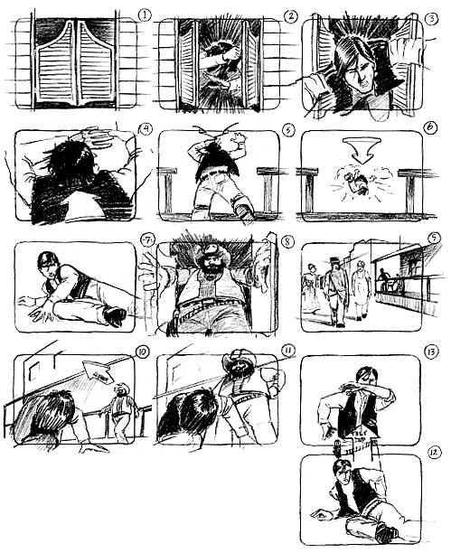

Psycho
Shower Scene Story Board Assignment

- Watch the clip of the SHOWER SCENE. Repeatedly (linked on our Website)
- Try to create the story board to 16 shots IN ORDER. (Not necessarily consecutive!)
- Pay attention to the FRAMING, and how things FILL UP the screen.
- Remember: you need not draw WELL, but neatly.
- This is not DIFFICULT, but it is time consuming.

The blank story boards are also on the website!

